Supply Chain Management (SCM) — NPTEL
Week 9 · Session 5: DEA — Linearization, Excel Solver & Interpretation of Results
1. Recap — Session 4
- DEA model formulated: maximize weighted output ÷ weighted input for each facility, subject to all facilities' efficiency ≤ 1
- Problem: the model is non-linear — decision variables appear in both numerator and denominator
- This session: linearize the model, solve in Excel Solver, and interpret results
2. Converting Non-linear DEA to Linear Programming
- Why non-linear? Both numerator (V1·Y1 + V2·Y2) and denominator (U1·X1 + U2·X2) contain decision variables → Y/X type = non-linear
- Strategy: apply two separate transformations — one for constraints, one for objective

 | Transformation | Why it works
1 | NON-LINEAR constraint:  (V·Y + ...) / (U·X + ...) ≤ 1  → LINEAR form:  V·Y + ... − U·X − ... ≤ 0 | Cross-multiply denominator to right side. Denominator is positive, so inequality direction stays.
2 | NON-LINEAR objective:  Maximize (V·Y) / (U·X)  Add constraint: U·X = 1  → LINEAR objective:  Maximize V·Y | Fix denominator = 1 via an extra equality constraint. Max score ≤ 1 is preserved. Objective reduces to maximizing numerator alone.

★ After linearization: all 9 efficiency constraints become linear AND objective function becomes linear → standard LP, solvable with Simplex.

3. Linearized DEA Model — Facility 1 (Worked Example)
Objective Function (linear)
Maximize: 92·V1 + 80·V2

Constraint 0 — Denominator = 1 (linear, changes per facility)
32·U1 + 88·U2 = 1

Constraints 1–9 — Efficiency ≤ 1 for All Facilities (linear, fixed)
F1: 92·V1 + 80·V2 − 32·U1 − 88·U2 ≤ 0
F2: 88·V1 + 78·V2 − 35·U1 − 94·U2 ≤ 0
... [repeat for F3 through F9 — same structure]

Decision Variables & Non-negativity
- V1, V2, U1, U2 ≥ ε (use ε = 0.000001 — never exactly 0)
- Solve 9 times — only objective and Constraint 0 change (facility's own data). C1–C9 stay identical.

4. Generalized DEA Model (m inputs, s outputs, n facilities)
- In real-world: may have m inputs, s outputs, n facilities — generalized form:

Component | Expression (linearized, for facility p) | Notes
Objective (changes per run) | Maximize:  Σ(k=1 to s) V_{k} · Y_{kp} | Weighted sum of outputs for facility p. Vk = weight of output k.
Additional constraint (changes per run) | Σ(j=1 to m) U_{j} · X_{jp} = 1 | Fixes denominator = 1. Only the input values of facility p appear here.
Efficiency constraints (same all 9 runs) | For each i = 1 to n:  Σ V_{k}·Y_{ki} − Σ U_{j}·X_{ji} ≤ 0 | Ensures no facility's efficiency exceeds 1. All 9 facilities appear. Does NOT change across runs.
Non-negativity | V_{k} ≥ ε > 0 for k = 1 to s  U_{j} ≥ ε > 0 for j = 1 to m | Use ε = 0.000001 (not 0) — avoids zero weights that imply a parameter has no importance.

- Key notation: V_{k} = weight of output k (k=1 to s), U_{j} = weight of input j (j=1 to m), Y_{kp} / X_{jp} = output k / input j value of facility p

5. Excel Solver — Setup & Steps
- Use Simplex LP (model is now fully linear after transformation)
- Run solver 9 times — one per facility. Use VLOOKUP to auto-switch coefficients when facility changes

1 | Enter data & formulas | Put input/output data + decision variable cells (V1,V2,U1,U2 = 0 initially). Use VLOOKUP to auto-fill coefficients when facility changes.
2 | Set objective cell | Cell = 92·V1 + 80·V2 (for Facility 1). Set Solver to Maximize this cell.
3 | Changing variable cells | B17:E17 → V1, V2, U1, U2. Initially all = 0; Solver finds optimal values.
4 | Add Constraint 0 | 32·U1 + 88·U2 = 1 (denominator = 1). Enter as equality constraint in Solver.
5 | Add Constraints 1–9 | 92·V1+80·V2−32·U1−88·U2 ≤ 0 for F1, and similarly for F2–F9. Enter all 9 as ≤ 0.
6 | Non-negativity & method | Check 'Make unconstrained variables non-negative'. Set lower bound = ε (not 0). Use Simplex LP.
7 | Solve & record | Click Solve → record efficiency score + weight values (V1,V2,U1,U2). Change facility → re-run Solver 9 times total.

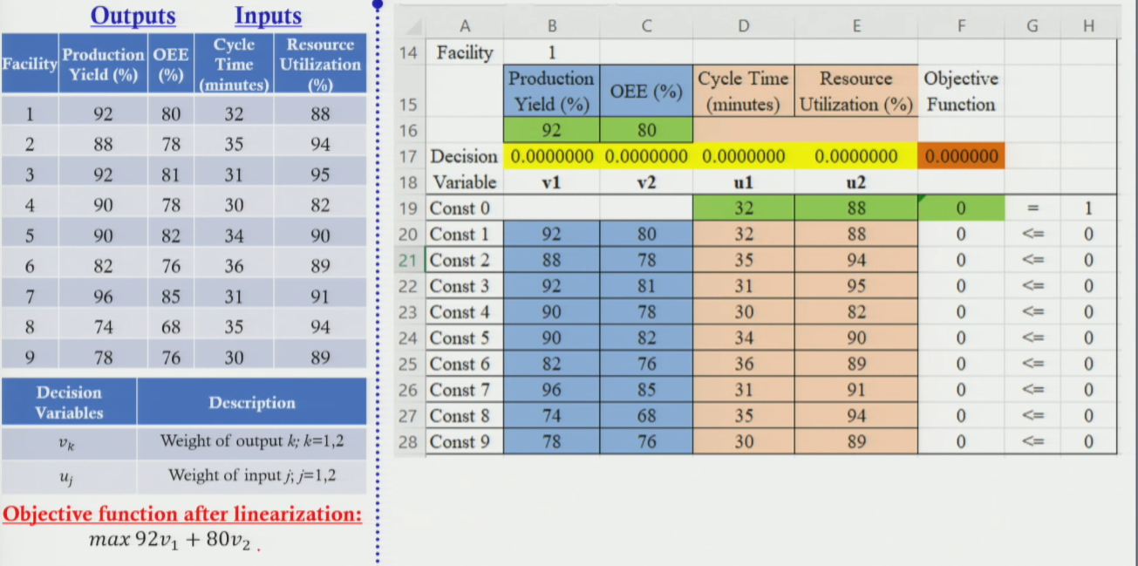
Why ε instead of 0 for lower bounds?
- If lower bound = 0, Solver may return weight = 0 for some parameters
- Weight = 0 would imply that parameter (e.g., cycle time) has zero importance — misleading
- Setting ε = 0.000001 ensures all 4 parameters retain at least minimal importance in the final solution

6. Efficiency Results — All 9 Facilities
Fac. | Efficiency | Gap | Highest Weight Parameter | Recommended Focus | Status
F1 | 95.72% | 4.28% | OEE (V2 highest) | Increase OEE | Not efficient
F2 | 87.00% | 13.00% | OEE & Resource Util | ↑ OEE + ↓ Resource Utilization | Not efficient
F3 | ~92% | ~8% | — | — | Not efficient
F4 | 100% | 0% | Efficient | Already on frontier | Efficient ★
F5 | ~90% | ~10% | — | — | Not efficient
F6 | ~88% | ~12% | — | — | Not efficient
F7 | 100% | 0% | Efficient | Already on frontier | Efficient ★
F8 | 76.00% | 24.00% | OEE (V2 = 0.011 highest) | Increase OEE (68 → 70–75+) | Not efficient
F9 | 92.00% | 8.00% | Cycle Time (U1 = 0.033) | Reduce cycle time | Not efficient

- Efficient facilities: F4 and F7 (100%) — on the efficient frontier, serve as benchmarks
- Least efficient: F8 (76%) — 24% improvement potential
- Second least efficient: F2 (87%) — 13% gap

7. How to Interpret DEA Results — Weight-Based Focus
- After solving for a facility, look at the optimal weights (V1, V2, U1, U2)
- The parameter with the highest weight is where efficiency is most sensitive
- Focus improvement effort on that parameter for maximum gain

Scenario | Meaning | Action
Efficiency = 100% | Facility is on the efficient frontier | No improvement needed — benchmark for others
Efficiency < 100% | Facility is below the efficient frontier | Find highest-weight parameter and focus there
Output weight (Vk) is highest | That output is most sensitive to efficiency | Increase that output value to improve efficiency faster
Input weight (Uj) is highest | That input is dragging efficiency down | Reduce that input value to improve efficiency faster
Multiple high weights (mixed) | Both output and input contribute to inefficiency | Improve both simultaneously (e.g., F2: ↑ OEE + ↓ Resource Util)

Worked Examples
- Facility 8 (76% efficient): V2 = 0.011 (highest) → focus on increasing OEE (currently 68, peers achieve up to 85)
- Facility 9 (92% efficient): U1 = 0.033 (highest) → focus on reducing cycle time
- Facility 2 (87% efficient): Both V2 (OEE) and U2 (Resource Utilization) significant → increase OEE AND reduce resource utilization
Session Summary
- Non-linear → LP: (1) cross-multiply constraint denominators; (2) add denominator = 1 constraint for objective
- Generalized form: Maximize Σ(Vk·Ykp) s.t. Σ(Uj·Xjp)=1 and Σ(Vk·Yki)−Σ(Uj·Xji)≤0 for all i
- Solver: Simplex LP, 9 runs, VLOOKUP switches facility. ε > 0 for lower bounds.
- Efficient: F4 and F7 (100%). Least efficient: F8 (76%).
- Interpretation: Highest weight parameter = priority improvement area for that facility
- DEA is useful for: benchmarking facilities, warehouses, DCs — any set of similar units with measurable inputs & outputs

★ Exam Tip: Linearization: (1) constraints → cross-multiply denominator; (2) objective → add Σ(Uj·Xjp)=1 to fix denominator at 1. Both steps are required.
★ Exam Tip: In DEA, ONLY the objective function AND the denominator=1 constraint change per facility. The 9 efficiency constraints (≤ 0) are identical across all 9 runs.
★ Exam Tip: Interpretation rule: find the highest weight (V or U) in the solver output. If V is highest → increase that output. If U is highest → decrease that input.
★ Exam Tip: Use ε (epsilon) as lower bound for weights, NOT 0. Zero weights make parameters appear irrelevant, which misrepresents the model.

